**Project Design Phase-II Data Flow Diagram & User Stories**

|  |
| --- |
| Date : 31st October 2022 |
| Batch NO:PNT2022TMID09289 |
| Project Name : Smart Fashion Recommender Application |
| Maximum Marks : 4 Marks |

# Data Flow Diagrams:

A data-flow diagram is a way of representing a flow of data through a process or a system.It uses defined symbols like rectangles, circles and arrows, plus short text labels, to show data inputs, outputs, storage points and the routes between each destination.

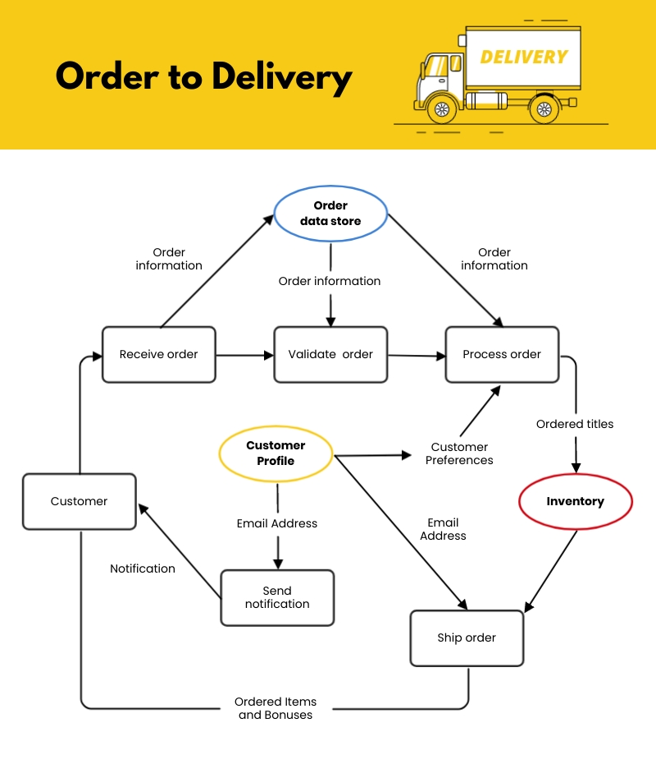

# User Stories

Use the below template to list all the user stories for the product.

|  |  |  |  |  |  |  |
| --- | --- | --- | --- | --- | --- | --- |
| **User Type** | **Functional Requirement (Epic)** | **User Story Number** | **User Story / Task** | **Acceptance criteria** | **Priority** | **Release** |
| Customer (Mobile user/Web  user) | Registration | USN-1 | As a user, I can register for the application by entering my email, password, and confirming my password or by by giving mobile number and OTP | I can access my account / dashboard | High |  |
|  |  | USN-2 | As a user, I will receive confirmation through email as well as through SMS once I have registered for the application | I can receive confirmation email & SMS and then click confirm | High |  |
|  |  | USN-3 | As a user, I can register for the application through Facebook,Google account | I can register & access the dashboard with  Facebook Login, Gmail | Low |  |
|  |  | USN-4 | As a user, I can register for the application through Twitter |  | Medium |  |
|  | Login | USN-5 | As a user, I can log into the application by entering email & password or through mobile number and OTP |  | High |  |

|  |  |  |  |  |  |  |
| --- | --- | --- | --- | --- | --- | --- |
| Customer Care Executive  Administrator | Application | USN-7  USN-8 | As a customer care executive i can solve the login issues and other issues of the application.  As an administrator I can upgrade or update the application. | I can provide support or solution at any time 24*7  I can fix the bugs which arises for the customers and users of the application | Medium  Medium |  |